DaZona Life and Learning Center
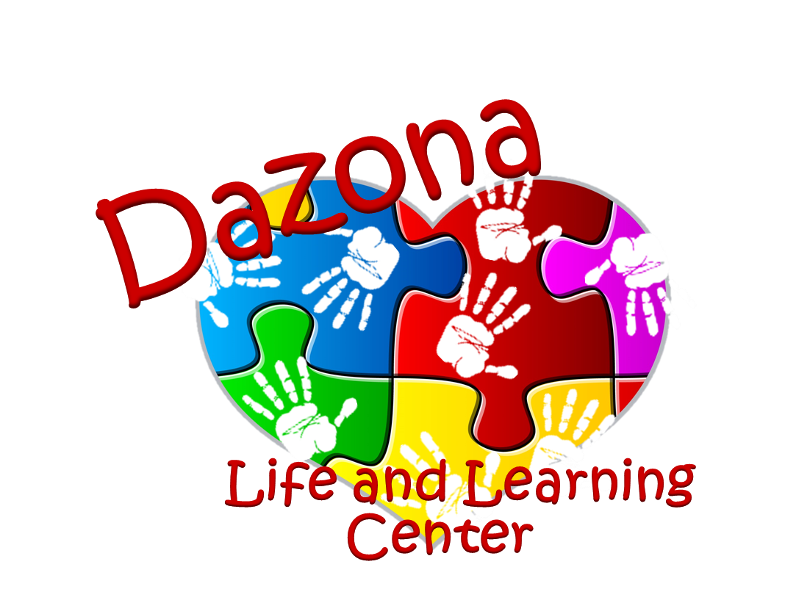
Operational Policies Handbook
DaZona Life and Learning Center is dedicated as a safe haven in what is an otherwise stormy sea of life for the exceptional child. DaZona’s goal is to continue towards the Individual Education Plans established by their parents and teachers. It is our belief that with a community endeavor these young people will successfully reach the goals set by their parents, teachers, and themselves.
Purpose
The purpose of DaZona Life and Learning Center is to establish a location that serves the needs of the adult special needs population in our community. Our goal is to serve the entire family as they help their child make a way in our community.
With the goal of helping our clients enhance their quality of life and teach then life sustainability, DaZona strives to offer an academic atmosphere in which they will gain a sense of independence and pride in their accomplishments. Our program offers our clients training in academics, life skills, social skills, vocational skills, computer skills, cooking, arts and crafts and more.
Hours of Operation
DaZona is open Monday through Friday from 7:30 a.m. to 4:00 p.m. for Day Habilitation and Respite Care services. DaZona provides 5 hours of Day Hab services each day from 8:00 a.m. to 1:00 p.m. Respite Care or Extended Care services are offered following the 5 hours of Day Hab from 1:00 p.m. to 4:00 p.m. Drop off will begin at 7:30 a.m., clients must be dropped off by 10 a.m. for Day Hab services. Parents/Guardians must sign clients in and out upon arrival and departure. The Day Habilitation hours may be flexible but must consist of 5 hours each day. Any time after the 5 hours of attendance for Day Hab will be considered Respite Care and will be billed accordingly. Clients must be picked up by 4 p.m. Any time after 4 p.m. will be charged $1 per minute.

DaZona Life and Learning Center observes a number of Federal holidays, to include: New Year’s Eve and New Year’s Day, Memorial Day, 4th of July, Labor Day, Thanksgiving Day, and the day after Thanksgiving. We will also be closed for a full week for Christmas Holiday. DaZona may also close two additional days for staff training.
Clients are expected to attend year round. The Director of DaZona must be notified in the case of expected extended absences (such as family vacations). In cases of excessive absences, if we have a client who can take your slot full time, we will be forced to give your slot to the other client. Medical emergencies will not be counted against client attendance in this capacity.
Enrollment Procedures
Individuals wishing to enroll at DaZona Life and Learning Center must first fill out an application and submit it to the Director. Parents/guardians are asked to complete the entire application and include all necessary paperwork as requested. Not submitting completed paperwork may delay a client’s start time. Once the application is processed, the Director will set up a client assessment and planning conference. This assessment and planning conference usually includes the client, parent or guardian, the individual service coordinator or case worker, and DaZona Life and Learning Center’s Director and other staff. At this planning conference, the client’s individual service plan is developed and goals are established. Once this meeting has taken place, justifications are sent to the sponsoring agency and DaZona Life and Learning Center will await authorization of services. Once the authorization is sent to DaZona Life and Learning Center, a start date can be arranged. All paperwork must be in place prior to start date. Guardians are encouraged to call the Center at (254-699-2186/2187) if they have any questions or if there will be any delays in completing the paperwork prior to the start date. If any of the policies of DaZona Life and Learning Center are changed for any reason, guardians will be notified 2 weeks prior to the change taking place.
Rates and Fees
Private Pay Tuition for Day Habilitation Services at DaZona begins at $25 per day (5 hours of Day Hab) and is based on the client’s level of need. Respite or Extended Care service fees are $10 per hour for private pay and begin immediately after the 5 hours of Day Hab are completed.
Late Fees
Tuition for DaZona will be billed to the HCS provider or parent/guardian at the end of each month. A late fee of $25 will be added to any bill not paid after 10 days from the date it is due.
Dress Code
Due to the level of activity clients participate in at DaZona, it is important that clients be properly attired. Physical activity is an important part of the daily program at DaZona, and often clients are given the opportunity to participate in outside activities, arts and crafts, and more. Therefore we ask that DaZona clients follow the dress code below:

- No open-toed shoes. Tennis shoes are preferred for physical activity
- Dress for the weather. Bring proper outerwear such as coats, hats and gloves during cold weather. Shorts are allowed during the warmer months and are encouraged. Shorts must be no shorter than 3 inches above the knee.
- Please ensure that attire is appropriate for the environment.
  - Bra-straps and underwear should not be visible.
  - Cleavage should not be visible.
  - Sheer or see-through material is not allowed unless a tank top or other clothing is worn underneath.
  - Clothing with obscene graphics or wording is not permitted
**If a client presents to DaZona with attire that is inappropriate, they may be sent home.
Bathroom Policy
Clients must be able to complete all toileting needs independently in order to meet enrollment criteria. DaZona staff will not provide clients with assistance in toileting needs including but not limited to: wiping/cleaning of genitals and buttocks, changing of diapers, colostomy bags or catheters, lifting or positioning clients onto toilet, changing of clothes. DaZona staff will assist clients by prompting clients to: use the restroom, clean/wipe genitals and buttocks, change diapers or clothing, and/or wash their hands. DaZona staff will assist clients with buttons and/or zippers and removing/putting on of shoes as needed.
Parental Participation with Clients
Parents/Guardians are encouraged to participate in all programs of DaZona Life and Learning Center. Parents/Guardians may accompany clients on field trips, help with classroom activities, and have lunch with their clients or just visit in the client’s classroom. Parents/Guardians are welcome to visit the center at any time and observe their client or the center’s operations and program activities without securing prior approval. It is recommended, however, that you check with the Director of DaZona prior to your visit to make sure clients will be on campus the day of the visit. If you plan to accompany the class on a field trip it is also recommended that you let the staff know ahead of time so that we can plan for transportation.
Open Door Policy
It is the policy of DaZona Life and Learning Center to maintain an open door policy. Parents or guardians may visit the center at any time to discuss problems, concerns, or suggestions with staff without an appointment. Some of the greatest ideas for improvements come from our parents and guardians.

Parents and guardians may also come in and talk to the Director anytime she is available and on site. The parents or guardians may schedule appointments with the Director and other pertinent participants if a meeting is needed to make changes in the client’s program, to discuss any concerns, or answer any questions.
Parent/Guardian Notifications
Information to Parents/Guardians will be distributed through various methods. Accidents and behavioral incidents will be shared with parents/guardians verbally and in a written incident report. A copy of the incident report will be kept in the clients file. General information is posted in the Center, in the DaZona Newsletter, or on the DaZona website. Other information may be written and sent home with the client.
Text message reminders and notifications are also available for incidences such as event reminders and inclement weather closures. In emergencies, guardians will be notified by phone. Program changes will be shared with parents and guardians at face to face meetings with the DaZona Director, parent, guardian, service coordinators, and agency case worker at a preset meeting time or at the individual client’s annual planning conference.
Progress notes will be completed for each of our students and sent to the HCS service provider on a weekly basis. Parents/guardians typically do not receive copies of the weekly progress notes but can be provided upon request. Progress reports will be completed for each student on a monthly basis and copies will be sent to parents/guardians. These progress reports will inform parents/ guardians what the clients are working on and what level of competency they have acquired.
Emergency or Inclement Weather Closing
We make every attempt to remain open during inclement weather, but there may be times when we experience late openings, early closings, or forced all day closings. The policy of DaZona Life and Learning Center of Texas is to follow the closing schedule of Killeen Independent School District. If KISD indicates that they will be closed, DaZona Life and Learning Center will be closed as well. Please listen to the radio for information regarding school closings, or log onto DaZona Life and Learning Center website. Text message alerts are also available for this type of notification.
Illness and Exclusion Criteria
One of the most serious challenges facing group care situations is preventing illness. The staff will strive to maintain the highest standards of cleanliness. Proper hand washing procedures are followed and taught to the clients. All restrooms and classrooms are cleaned by our staff on a daily basis. One of the best ways to prevent the spread of disease is to have strictly enforced standards regarding the exclusion of ill clients. We will need your help for this. Please read the following information carefully:
According to the Texas Department of Family and Protective Services, which operates the Client Care Licensing Division, the following Minimum Standards regulations apply to our licensed program:
You must not bring an ill client into the program if one of the following exists:
1. The illness prevents the client from participating comfortably in center activities.
2. The illness results in a greater need for care than the staff can provide without compromising the health and safety of other clients in care.
3. The client has any one of the following:
a. An oral temperature of 100.4 degrees or greater or armpit temperature of 99.4 degrees or greater
b. Symptoms and signs of possible, even severe illness such as lethargy, breathing difficulties, uncontrolled diarrhea, vomiting- two or more episodes in 24 hours, rash with fever, mouth sores with drooling, behavior changes, or other signs that the client may be severely ill; or
c. A health care professional has diagnosed the client with a communicable disease.
If a client becomes ill while in our care, we will:
a. Contact the guardian to pick up the client as soon as possible.
b. Care for the client apart from the other clients.
c. Give appropriate attention and supervision until the guardian picks up the client,
d. Staff and client will give extra attention to hand washing and sanitation if the client has diarrhea or vomiting.
Parents or Guardians are required to pick up the client as soon as possible. If a parent or guardian is unable to pick the client up, they are responsible for arranging for another person to pick up the client.
Clients may return to the Center after being excused from care, based on one of the following conditions:
1) Client is free of the symptoms, without medication for at least 24 hours
2) A physician approves, in writing, that they are aware of the specific symptoms in question and they have determined that the client is no longer contagious and is able to return and participate in DaZona activities.
** If your client is sent home due to illness, the client will not be admitted to the center the next day because the 24 hour period will not have elapsed**
Immunization Requirements
We must have a copy of current immunizations for each client. Guardians are required to provide a copy of the most current immunizations. If there is a reason, due to your client’s special needs, that he or she cannot get certain immunizations, please provide the center with a letter from your physician as to why he or she may not get this particular immunization at this time. Updated immunization records should be provided at the time the client receives the immunization. A list of required immunizations is available from the director, the local health department, or your physician.
Procedures for dispensing medications
DaZona staff is only allowed to administer medications as directed by the client’s HCS provider and/or medical provider. If your client requires medication to be administered by DaZona staff, the provider must provide DaZona staff with training/direction prior to the first dose being administered.
Clients requiring medication administration must bring that medication in its original container and the prescription must match the doctor’s order in the client’s file. DaZona staff will not administer medications that are not in the original container or do not match the physician’s prescription.
DaZona staff will administer over the counter medication only as directed by the HCS provider and/or medical provider. If a client requires over the counter medication such as Tylenol or Motrin, the medication must be included on the medication form with specific instruction for administration and be in the original container clearly labeled with client’s name and instructions for medication. DaZona will not provide over the medication for clients to use.
If a physician makes a change in a client’s medication, a new medication form must be filled out by that physician. If a client does not take medication at DaZona Life and Learning Center, but takes medication at home, the bottom part of the medication form must be filled out with all the medications the client takes so we have that information in the case of an emergency. This information must be kept current. If a client takes no medication, the medication form should state no medications taken.
Injuries and Medical Emergencies
Minor Injuries: minor injuries will be cared for at the Center. Guardians will be notified of injuries by the program staff. All our staff is certified in CPR and First-aid. All injuries that occur at DaZona will be thoroughly documented on an incident report and a copy will be kept on file at DaZona.
Medical Emergencies: If a serious injury or other medical emergency occurs, the parent and or guardian will be notified immediately. For this reason, emergency contact information must be kept up to date. If guardians cannot be contacted, emergency procedures for the center will involve the DLLC staff, police, or paramedics. The emergency medical authorization to treat is included in the client’s application and must be filled out and signed, prior to the client starting services. If required, the client will be taken to the hospital listed on the application, unless the injury or illness is such that the paramedics are required to go to the closest hospital, which is Metroplex Hospital.
Procedures for the Release of Client
It is the policy of DaZona Life and Learning Center to only release client to parents, guardians, or those listed on the application as designees for pick up. Guardians must make sure that the names, addresses, and phone numbers of designees are current and correct. Clients will not be released to anyone not on the application without prior approval from parents or guardians. If a staff member is not familiar with the individual picking up a client, they may be asked to present proper identification at the time of pick-up before the client is released.
Custody Issues
The center cannot legally restrict the non-custodial guardians from visiting the client, reviewing the client’s records or picking the client up unless the center has been furnished with legally filed, executed and current documents. Copies of all court documents must be submitted to the center, as it is our only means of protection for your client. Our purpose is to protect the interests of the client and not to mediate differences. In case of conflicts, the proper authorities will be contacted.
Meals and food service practices
DaZona Life and Learning Center does not serve lunches. Due to the wide variety of special needs of our clients, guardians are responsible to prepare the client’s lunch and send it with any particular instructions to the client’s teacher. DaZona Life and Learning Center does not provide a snack in the morning and a snack in the afternoon. Clients who are tube fed must have the formula sent for them daily. We do not refrigerate anything overnight. If a client has specific allergies or whose diet is restricted from eating regular snack items, it is recommended that guardians send these as well.
At this time, it is required for each client to bring their own lunch and a snack.
DaZona currently provides cooking classes twice per week. The recipes chosen for these classes are intended to create small portions for each student to consume. The portions will not make adequate amounts to constitute a full meal for any student, therefore we urge parents/guardians to ensure the student bring their own lunch every day they are at the center. If a student does not eat their lunch, it will be sent back home with them that day.
Please make sure that any client allergies are annotated in the client files and that the DaZona staff is kept up-to-date on any changes to allergies.
Discipline and Guidance Practices
It is the policy of DaZona Life and Learning Center to provide our services in the least restrictive manner possible. If discipline becomes necessary, the staff is trained first to use their communication skills to find the cause of the misbehavior, remove the problem if there is something causing irritability, teaching the client to work out problems on his/her own and/or redirect the client to another activity.
Staff is trained to watch for stressors which may trigger inappropriate behavior such as flashing lights, bright lights, too much commotion, too much noise, clients teasing one another, lack of self-esteem, chemical imbalance, potential seizure activity, inadequate sleep, illness or hunger, etc.
Staff will use the least restrictive approaches first. If a client becomes violent, staff may hold a client’s hands to keep the client from hurting themselves, hurting others, or destroying property. If the client must be restrained further, staff is trained in the proper procedures for a violent situation to keep all clients and staff safe.
DaZona Life and Learning Center does NOT permit:
1. Corporal punishment or threats of corporal punishment
2. Punishment associated with food, naps, or toilet training
3. Pinching, shaking, or biting a client
4. Putting anything in or on a client’s mouth
5. Humiliating, ridiculing, rejecting, or yelling at a client
6. Subjecting a client to harsh, abusive, or profane language
7. Placing a client in a locked or dark room, bathroom, closet with the door closed
8. Requiring a client to remain silent or inactive for inappropriately long periods of time.
Discipline must be:
1. Individualized and consistent for each client.
2. Appropriate to the client’s level of understanding, and
3. Directed toward teaching the client acceptable behavior and self-control.
Methods of discipline and guidance permitted by DaZona staff:
A staff member may only use positive methods of discipline and guidance that encourage self-esteem, self- control, and will include the following:
1. Using praise and encouragement of good behavior instead of focusing only upon acceptable behavior;
2. Reminding a client of behavior expectations daily by using clear, positive statements.

3. If a client becomes combative or aggressive, the student may be removed from the presence of other students until the behavior is corrected and parents/guardians will be notified. Depending on the level of combative or aggressive behavior, the client may be sent home for the day and a day of suspension may incur. After the third combative or aggressive incident, a client may be suspended from DaZona for a period of time to be determined by the Director of DaZona and client’s parent/guardian. If the combative or aggressive behavior continues, a client may be removed permanently from the center.
4. If a client becomes violent, the parent/guardian will be called to pick up the client immediately. The client will be removed permanently from the center after a second altercation.
***Severity Clause
If a client loses complete control and puts the lives of the other clients and staff in imminent danger, or uses a weapon of any kind that can result in death or dismemberment, or cause hospitalization/EMS assistance, the proper authorities will be called and the client will be removed permanently from the center.
Security
Security cameras are strategically positioned throughout our facility. This allows us to monitor our facility and clients more effectively and document incidences as they take place. We protect the privacy of our clients by keeping the information recorded on our cameras in house. Any questions regarding information captured on our security cameras should be made to the rogram Director, who will schedule a time for the film to be reviewed.
Grievance Procedure
We are committed to respecting the concerns and opinions of all our families. The staff of the center is available to discuss any concerns or challenges guardians face in the program. In the event an issue is not resolvable within the staff, the Executive Director is the person to contact.
Notice of Withdrawal
In order to provide a smooth separation for your client from the group as well as to provide parents or guardians on the waiting list notification of an opening, we require a written 14 day notice of withdrawal.
Termination of Services
Being a model program and very unique in this field, DaZona Life and Learning Center takes its policies and procedures seriously. They are designed with the best interests of adults for their development and welfare. Therefore, the center will terminate services for repeated violation of program policies and procedures. When a family is found to be in violation of the rules and guidelines, the following procedures will be taken:
1. Notice to bring the situation to your attention
2. Written warning of suspension
3. Client may not attend for three days
4. Written notice of termination if problem continues; then
5. Termination of Services
Reasons for Termination
1. Attendance (infrequent)
2. Fees (unpaid)
3. Medical (not up to date as required)
4. Behavioral (disruptive or dangerous)
5. Repeated late pick up after closing time
6. Refusal to cooperate
7. Noncompliance with policies and procedures
Adult Abuse and Neglect
In an effort to protect the interests, health and safety of clients, the State of Texas requires anyone who suspects adult abuse and neglect to report it to the proper authorities. The center staff has been trained to identify the signs and symptoms of abuse and neglect. All suspect indicators will be documented and reported. The Center is required by law to cooperate with any investigation of adult abuse and neglect. You will be notified if your client is questioned as part of an investigation.
If your client sustains injuries at home or on weekends, please notify the staff as unreported or suspicious bruising, burns, cuts, or other physical injuries MUST be reported to APS. IT IS THE LAW.
Staff Training
DaZona Life and Learning Center provides staff that is committed to caring and nurturing the clients as well as helping them achieve their individual goals. Staff is trained in a 40 hour training session each year. DaZona Life and Learning Center may close for two regular days to train staff. You will be notified of these dates well in advance of closing so you will be able to make the appropriate arrangements.

Tuberculin Testing Requirements
DaZona Life and Learning Center requires all employees to have a TB test prior to employment. Should the TB test be positive, further testing will be required before the employee can interact with the clients. This testing often requires an x-ray. A positive TB test does not necessarily mean the employee has TB. DaZona Life and Learning Center will take precautions to assure the health of its clients and staff through these tests.
Volunteers
DaZona encourages volunteer participation within the center. Parents/Guardians are encouraged to volunteer at the center. We also frequently have individuals from the community volunteer to help at the center and interact with DaZona clients. All volunteers must pass a background check prior to interacting with our clients.
DaZona also partners with colleges and universities in our area to provide graduate counseling students opportunities to volunteer at DaZona in order to earn credits for their school program. These Graduate students will often interact with our students based on the needs of their program and DaZona will often utilize the knowledge and experience of these students to aide in the instruction and education of our students.

DaZona Life and Learning Center

By signing the form below I agree to abide by all rules and policies explained to me throughout this book. My signature means I have a full understanding of the policies and procedures of DaZona Life and Learning Center of Texas and shall comply with all requirements of being a part of this program.

Client printed name: __________________________________________________________________

Parent/Guardian Signature:_____________________________________________________________

Date: _____________________________________

Director Signature:_____________________________________ Date:_______________________

DaZona Life and Learning Center is a non-profit day rehabilitation center for adults with special needs.
14140 HWY 195
Killeen, Texas 76542
254-699-2186/2187
Email: DaZona2013@gmail.com
Director: Crystal Passmore

